**Resize node pools in Azure Kubernetes Service (AKS)**

https://learn.microsoft.com/en-us/azure/aks/resize-node-pool?tabs=azure-powershell.

Due to an increasing number of deployments or to run a larger workload, you may want to change the virtual machine scale set plan or resize AKS instances. Node size.

Assume you want to resize an existing node pool, called ‘**nodepool1’**, from SKU size Standard_DS2_v2 to Standard_DS3_v2. To accomplish this task

Or

To resize a node pool in Azure Kubernetes Service (AKS), you can create a new node pool with the desired SKU, move workloads from the old node pool to the new one, and then remove the old node pool

1. Create a new node pool with the desired SKU. For example, if you want to resize an existing node pool called ‘**nodepool1’** from Standard_DS2_v2 to Standard_DS3_v2, you can create a new node pool called ‘**mynodepool’** with the Standard_DS3_v2 SKU.
2. Move workloads from ‘**nodepool1’** to ‘**myodepool’**
3. Remove ‘**nodepool1’**

Before resizing:



**Create a new node pool with the desired SKU**

Azure PowerShell

Use the New-AzAKSNodePool cmdlet to create a new node pool called **mynodepool2** with three nodes using the **Standard_DS3_v2** VM SKU.

After a Few minutes, the new node pool has been created.

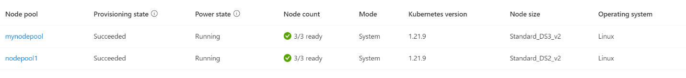

**Cordon the existing nodes**

Cordon, when you did this, the new pods won’t be schedule on the ‘**nodepool1’**  but the existing pods will continue to run until they are moved to ‘**mynodepool1’**

‘**kubectl get nodes**. Your output should look like the following:

Bash Copy

|  |
| --- |
| **NAME STATUS ROLES AGE VERSION**  **aks-nodepool1-31721111-vmss000000 Ready agent 7d21h v1.21.9**  **aks-nodepool1-31721111-vmss000001 Ready agent 7d21h v1.21.9**  **aks-nodepool1-31721111-vmss000002 Ready agent 7d21h v1.21.9** |

‘**kubectl cordon <node-names>’,** specify the desired nodes in a space-separated list.

Bash Copy

|  |
| --- |
| **kubectl cordon aks-nodepool1-31721111-vmss000000 aks-nodepool1-31721111-vmss000001 aks-nodepool1-31721111-vmss000002** |

|  |
| --- |
| OutputCopy  **node/aks-nodepool1-31721111-vmss000000 cordoned**  **node/aks-nodepool1-31721111-vmss000001 cordoned**  **node/aks-nodepool1-31721111-vmss000002 cordoned** |

**Drain the existing nodes**

Drain: That all the existing pods on that node will be gracefully deleted and rescheduled on other nodes in the cluster.

|  |
| --- |
| **kubectl drain aks-nodepool1-31721111-vmss000000 aks-nodepool1-31721111-vmss000001 aks-nodepool1-31721111-vmss000002 --ignore-daemonsets --delete-emptydir-data** |

**Remove the existing node pool**

To delete the existing node pool, use the Azure portal or the Remove-AzAksNodePool cmdlet:

|  |
| --- |
| Azure PowerShellCopy Open Cloud Shell  $params = @{  ResourceGroupName = 'myResourceGroup'  ClusterName = 'myAKSCluster'  Name = 'nodepool1'  Force = $true  }  Remove-AzAksNodePool @params |



After completion, the result is with new node pool, desired SKU size and the application pods running properly.

